**Expand and Collapse All in Treeview**

**Description**

The Widget is a Pluggable written in Custom Java Script Code. This Widget can be Used in Treeview to Expand and collapse the Complete Treeview. This works for Treeview created with multiple tree levels as well. It Expand All child Elements until there are no more child Elements on Clicking on Expand All Button. On clicking of Collapse All it collapses all the child node Elements.

**Typical usage scenario**

If you implemented a Tree kind of structure in your project with the help of Treeview widget you can just download this widget to Implement Expand and Collapse All Button for it.

**PreRequisites**

NA

**Features and limitations**

1. Users can Just Download and place the widget wherever they want to Implement Expand and Collapse All for a Treeview.
2. This Widget can both Expand and Collapse all the Child Nodes.
3. This Widget works only on the Treeview.

**Dependencies**

Requires 9.0.5 or above

**Installation**

First, we Need to Import the Widget using the .mpk file.

* A Mendix package (.mpk) file can store one or more widgets. You need to place the Mendix package file in your app directory to import it.
* The Pluggable Widget should be put in the Widgets folder of the App Directory to use it in the Mendix.

To import widgets, follow these steps:

1. Click the **App** menu and select **Show App Directory in Explorer**:

1. Open the widgets folder in your app directory and put your .mpk file of the Pluggable Widget there.
2. Open the **App** menu and select **Synchronize App Directory** to synchronize the changes in the app directory.

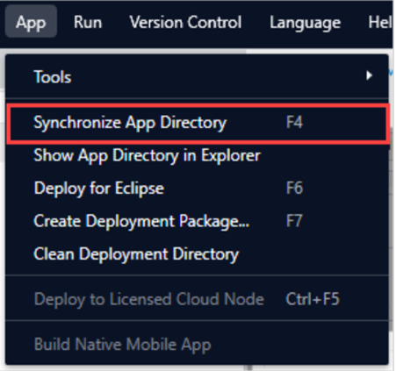

1. After completing the process Expand/Collapse All widget will appear in the Widgets Section.

1. Now you can use the Widget in your Project.

* Implementation:

For your reference if you want to build a pluggable widget then

Go for this module: <https://academy.mendix.com/link/paths/142/Build-a-Pluggable-Widget>

* In the Pluggable Widget I have written the Custom JS code.
* At First I have Created 2 Buttons for Expand All and Collapse All.
* The Expand All Button on click calls the ExpandChild Function which expands all the trees by calling the function Recursively.
* The Collapse All Button on click calls the collapseall which closes all the open trees.

After Implementing the Buttons will look Like this in the browser:

**Code:**

import { createElement } from "react";

import "./ui/Expandcollapseall.css";

export function ExpandChild(){

    var elem=document.getElementsByClassName("ant-tree-switcher ant-tree-switcher_close");

    var i;

function after_forloop() {

    setTimeout(function(){

        ExpandChild();

    }, 1);

    }

for(i=0;i<elem.length;i++){

    if(elem[i]){

    elem[i].click();

    }

    if(i==elem.length-1){

        after_forloop();

    }

}

}

export function Expandcollapseall(props) {

    const expandall=() =>{

        ExpandChild();

    };

    const collapseall=() =>{

        var elem=document.getElementsByClassName("ant-tree-switcher_open");

        var j;

        for(j=0;j<elem.length;j++){

         elem[j].click();

 }

    };

    return (

            <div className="button">

            <button type="button" onClick={expandall} class="btn mx-button spacing-outer-right-medium spacing-outer-top-medium spacing-outer-left-medium spacing-outer-bottom-medium btn-default" title="Expand All">

                <span class="glyphicon glyphicon-collapse-down">

                </span>&nbsp;

                Expand All</button>

            <button onClick={collapseall} class="btn mx-button spacing-outer-top-medium spacing-outer-bottom-medium btn-default">

            <span class="glyphicon glyphicon-expand">

            </span>&nbsp;

                Collapse All</button>

            </div>

    );

    }

**Configuration: NA**

**Category: Module**

**Subcategory: All**

**Visibility: Public Marketplace**

**Studio Pro Version: 9.0.5**